**Biology Revision: Types of Cell and**

Mastery Matrix Points

|  |
| --- |
| Describe the structure of plant, animal and bacteria cells, classifying as prokaryotic and eukaryotic cells. |
| Identify and explain the functions of sub-cellular structures |
| Describe the difference between ‘*cell differentiation’* and ‘*cell division’* |
| Describe how cells are specialised and explain their roles (*animal cells: sperm cells, nerve cells, muscle cells. Plant cells: root hair, xylem and phloem*). |
| Define ‘*tissue’, ‘organ’ and ‘organ system’* and explain how they work together to create a functioning ‘*organism’* |
| Compare and contrast electron and light microscopes |
| Define *‘magnification’* and ‘*resolution’* |
| Calculate magnification using a formula (magnification = size of image ÷ size of real object) |
| Explain how electron microscopy has improved our understanding of subcellular structures |
| Define and apply the prefixes ‘*centi’*, ‘*milli’*, ‘*micro’* and *‘nano’* |
| **Required Practical 1:** Use a light microscope to observe, draw and label a selection of plant and animal cells. A scale magnification must be included. |
| Compare and contrast electron and light microscopes |

Key Knowledge

Prokaryote cells –

e.g.

Eukaryote cells –

e.g.

Cell differentiation -

Cell division –

Tissue –

Organ –

System –

Label the cells:

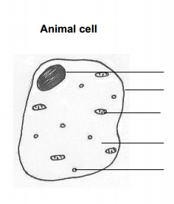

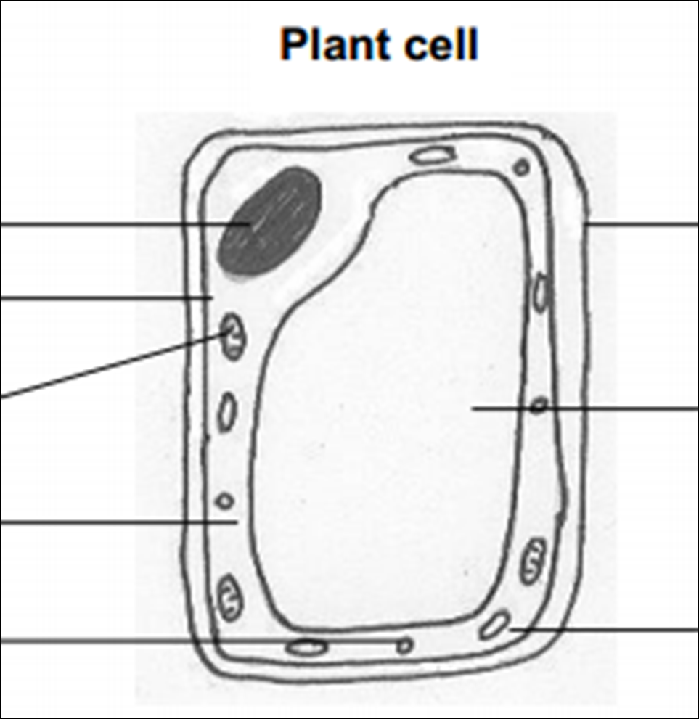

Definitions:

Magnification –

Resolution –

Equation:

Magnification =

**Microscopy**

Understanding and Explaining

1. Describe the structure of a bacteria cell.
2. Complete the table about the subcellular structures.

|  |  |  |
| --- | --- | --- |
| *Subcellular structure* | *Plant, animal or both?* | *Function:* |
|  |  |  |
|  |  |  |
|  |  |  |
|  |  |  |
|  |  |  |
|  |  |  |
|  |  |  |
|  |  |  |

1. Complete the table about specialised cells.

|  |  |  |
| --- | --- | --- |
| *Cell* | *Function* | *Adaptations* |
| Muscle |  |  |
| Sperm |  |  |
| Nerve |  |  |
| Root |  |  |
| Xylem |  |  |
| Phloem |  |  |

1. Compare when cell differentiation happens in plants to animals.
2. How have electron microscopes improved our understanding of cells?
3. Evaluate the pros and cons of light and electron microscopes.